Configurar SSL en Tomcat

Crear certificado  autofirmado en Windows.

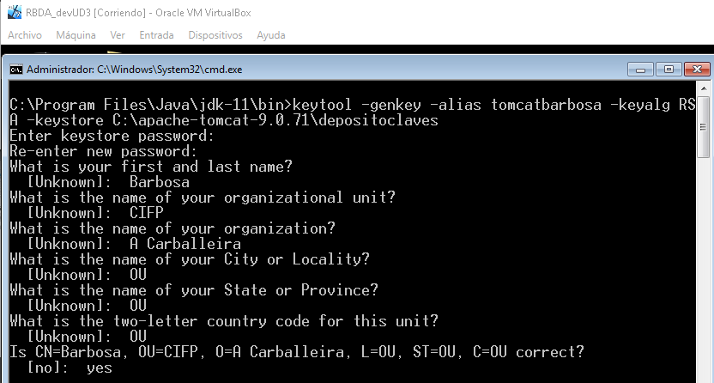

Configuramos https en **C:\apache-tomcat-9.0.71\conf\server.xml.**

**<Connector port="8443" protocol="org.apache.coyote.http11.Http11NioProtocol"**

**maxThreads="150" SSLEnabled="true"**

**scheme="https"**

**secure="true"**

**clientAuth="false"**

**sslProtocol="TLS"**

**keystoreFile="c:\apache-tomcat-9.0.71\depositoclaves"**

**keystorePass="abc123."**

**keyAlias="tomcatbarbosa">**

**</Connector>**

